Industrial Internship Report on
”Bank Management System”
Prepared by
Shivam Dhondkar

Executive Summary
This report provides details of the Industrial Internship provided by upskill Campus and The IoT Academy in collaboration with Industrial Partner UniConverge Technologies Pvt Ltd (UCT).
This internship was focused on a project/problem statement provided by UCT. We had to finish the project including the report in 6 weeks’ time.
My project was the development of a Bank Management System, a Java-based application designed to automate banking operations like account creation, secure transactions, and balance management.
This internship gave me a very good opportunity to get exposure to Industrial problems and design/implement solution for that. It was an overall great experience to have this internship.

TABLE OF CONTENTS
1 Preface 3
2 Introduction 4
2.1 About UniConverge Technologies Pvt Ltd 4
2.2 About upskill Campus 8
2.3 Objectives 10
2.4 Referance 10
3 Problem Statement 11
4 Existing and Proposed solution 12
5 Proposed Design/ Model 13
5.1 High Level Diagram 14
5.2 Low Level Diagram 15
5.3 Interfaces 16
6 Performance Test 21
6.1 Test Plan/ Test Cases 22
6.2 Test Procedure 23
6.3 Performance Outcome 23
7 My Learning 25
8. Future Scope 27

Preface
The transition from academic theory to industrial application is a cornerstone of professional development for any aspiring software developer. This report summarizes a comprehensive six-week industrial internship conducted in collaboration with upskill Campus (USC) and UniConverge Technologies Pvt Ltd (UCT). The primary objective of this tenure was to bridge the gap between classroom concepts of Java programming and the rigorous demands of real-world software deployment.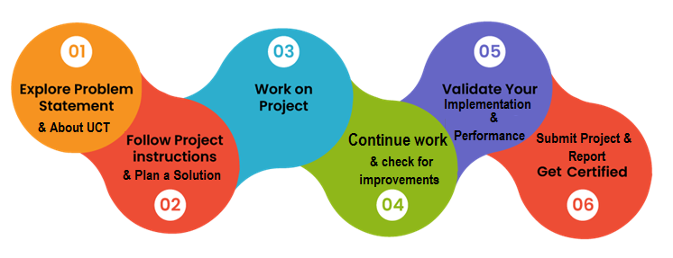
In today’s rapidly evolving tech landscape, technical proficiency in a language like Java is only the beginning. An internship provides the necessary exposure to the Software Development Life Cycle (SDLC), version control systems like Git, and the importance of structured documentation. This experience has been instrumental in shaping my understanding of how scalable backend systems are built and maintained in a professional environment.

Introduction

About UniConverge Technologies Pvt Ltd
A company established in 2013 and working in Digital Transformation domain and providing Industrial solutions with prime focus on sustainability and RoI.
For developing its products and solutions it is leveraging various Cutting Edge Technologies e.g. Internet of Things (IoT), Cyber Security, Cloud computing (AWS, Azure), Machine Learning, Communication Technologies (4G/5G/LoRaWAN), Java Full Stack, Python, Front end etc.

- UCT IoT Platform ()
UCT Insight is an IOT platform designed for quick deployment of IOT applications on the same time providing valuable “insight” for your process/business. It has been built in Java for backend and ReactJS for Front end. It has support for MySQL and various NoSql Databases.
- It enables device connectivity via industry standard IoT protocols - MQTT, CoAP, HTTP, Modbus TCP, OPC UA
- It supports both cloud and on-premises deployments.
It has features to
• Build Your own dashboard
• Analytics and Reporting
• Alert and Notification
• Integration with third party application(Power BI, SAP, ERP)
• Rule Engine

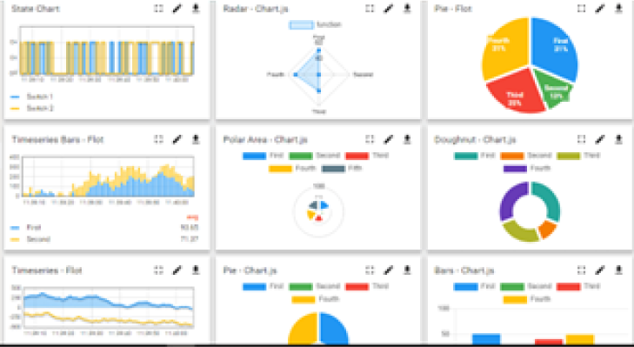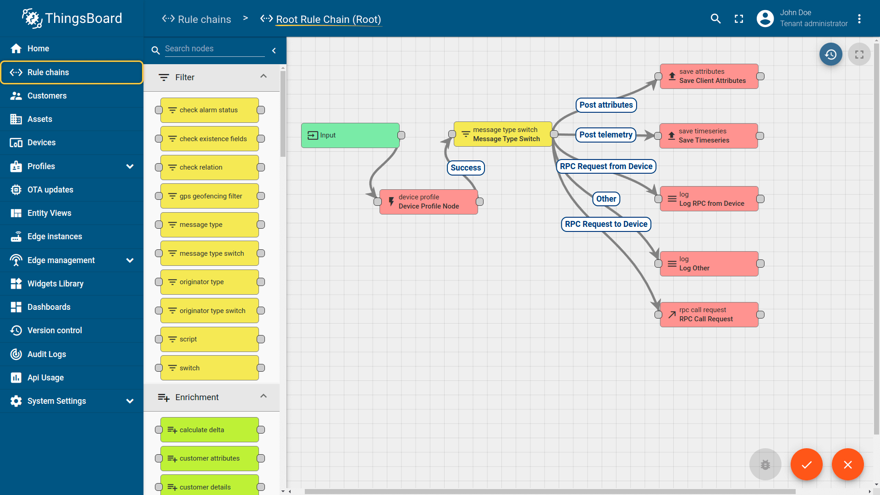

- Smart Factory Platform ()
Factory watch is a platform for smart factory needs.
It provides Users/ Factory
- with a scalable solution for their Production and asset monitoring
- OEE and predictive maintenance solution scaling up to digital twin for your assets.
- to unleased the true potential of the data that their machines are generating and helps to identify the KPIs and also improve them.
- A modular architecture that allows users to choose the service that they what to start and then can scale to more complex solutions as per their demands.
Its unique SaaS model helps users to save time, cost and money.
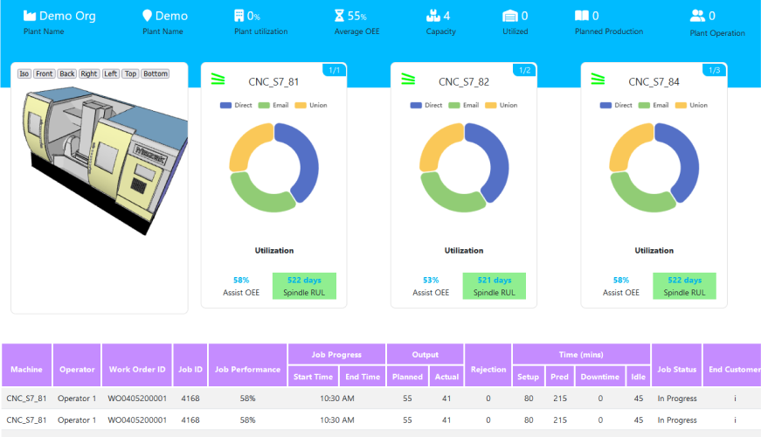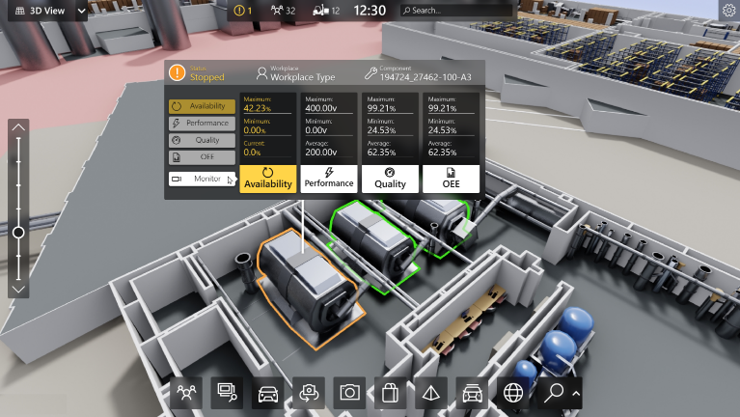

-  based Solution
UCT is one of the early adopters of LoRAWAN teschnology and providing solution in Agritech, Smart cities, Industrial Monitoring, Smart Street Light, Smart Water/ Gas/ Electricity metering solutions etc.
- Predictive Maintenance
UCT is providing Industrial Machine health monitoring and Predictive maintenance solution leveraging Embedded system, Industrial IoT and Machine Learning Technologies by finding Remaining useful life time of various Machines used in production process.
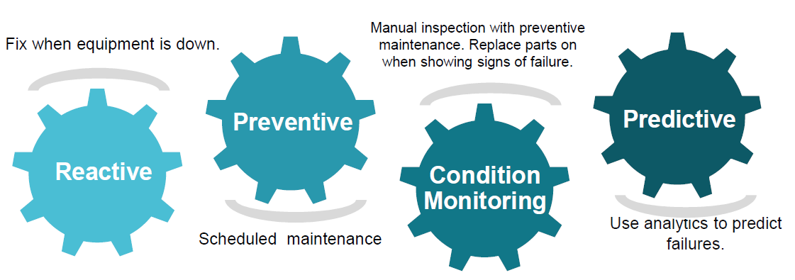

About upskill Campus (USC)
upskill Campus along with The IoT Academy and in association with Uniconverge technologies has facilitated the smooth execution of the complete internship process.
USC is a career development platform that delivers personalized executive coaching in a more affordable, scalable and measurable way.




Seeing need of upskilling in self paced manner along-with additional support services e.g. Internship, projects, interaction with Industry experts, Career growth Services
https://www.upskillcampus.com/
upSkill Campus aiming to upskill 1 million learners in next 5 year

The IoT Academy
The IoT academy is EdTech Division of UCT that is running long executive certification programs in collaboration with EICT Academy, IITK, IITR and IITG in multiple domains.

Objectives of this Internship program
The objective for this internship program was to
☛ get practical experience of working in the industry.
☛ to solve real world problems.
☛ to have improved job prospects.
☛ to have Improved understanding of our field and its applications.
☛ to have Personal growth like better communication and problem solving.

Reference
[1] https://www.geeksforgeeks.org/software-engineering/library-management-system/
[2] https://github.com/Pavith19/Book-Management-System
[3] https://www.youtube.com/watch?v=Vb738P3u7fA

Problem Statement
Develop a prototype of a Banking Information System in Core Java that provides a working preview of the key functionalities of a real banking system. The prototype should demonstrate the core features and flow of the system, showcasing its functionality and usability.
Key Functionality to Include in the Prototype:
- User Registration: Implement a simplified user registration process where users can provide basic details to create an account.
- Account Management: Develop the ability to create and manage user accounts, including assigning unique account numbers and tracking account balances.
- Deposit and Withdrawal: Enable users to make deposits and withdrawals from their accounts, updating the account balance accordingly.
- Fund Transfer: Implement a simplified version of fund transfer functionality, allowing users to transfer funds between their accounts or to other registered users.
- Account Statements: Provide users with a preview of their account statements, displaying transaction history, dates, amounts, and remaining balances.
- Password Protection: Develop a basic login system with password authentication to ensure secure access to user accounts.
- Error Handling: Implement basic error handling mechanisms to handle common exceptions, such as insufficient funds and invalid transactions, and display relevant error messages to users.
- User Interface: Design a user-friendly interface for the prototype that allows users to navigate through the system, perform banking operations, and view relevant information.

Existing and Proposed solution

Traditional banking systems in smaller institutions often rely on fragmented legacy software or manual ledger-based tracking. These methods suffer from several critical issues:
- Data Redundancy: Patient or account information is often duplicated across different files, leading to inconsistencies.
- Security Risks: Physical records or non-encrypted local databases are vulnerable to unauthorized access and physical damage.
- Latency: Simple tasks like balance reconciliation or transaction history retrieval require manual searching, which is time-consuming.

Code submission (Github link)
https://github.com/shivamdhondkar/Bank-Management-System

Report submission (Github link) :
https://github.com/shivamdhondkar/Bank-Management-System

Proposed Design/ Model
The proposed solution is a robust, centralized Bank Management System developed using a layered architecture. It is designed to automate core financial operations, ensuring that data handling is both secure and instantaneous. Unlike traditional manual methods, this digital solution leverages the power of object-oriented programming and relational database management to provide a reliable banking environment.
Technical Implementation Details:
- Modular Backend Development (Java): The system is built using Core Java, utilizing Object-Oriented Programming (OOP) principles such as Encapsulation and Inheritance. Each banking function—such as Account Creation, Deposit, Withdrawal, and Balance Inquiry—is treated as a separate module. This modularity ensures that the code is maintainable and that new features (like loan processing or fixed deposits) can be integrated without disrupting existing services.
- Relational Data Persistence (MySQL): To ensure that customer data and transaction histories are permanent and organized, the system employs MySQL. By using a relational database, the solution maintains ACID properties (Atomicity, Consistency, Isolation, Durability). This is critical in banking; for instance, it ensures that if a system failure occurs during a transfer, the database rolls back to the last consistent state, preventing any loss of funds.
- Secure Connectivity (JDBC): The bridge between the Java application logic and the MySQL data store is managed via Java Database Connectivity (JDBC). This allows the system to execute dynamic SQL queries safely. By using PreparedStatements, the proposed solution protects the database from common vulnerabilities like SQL injection, ensuring that user data remains confidential.
- Automated Transaction Logic: The solution replaces manual calculations with automated logic. For example, interest calculations and transaction fee deductions are programmed to happen instantly upon a trigger, eliminating human error. The system also includes automated validation checks to ensure that no withdrawal can occur unless the account meets the minimum balance requirement.
Key Advantages of the Digital Solution:
- High Availability: The system is designed to be accessible 24/7, allowing for transactions at any time without the need for physical bank staff.
- Searchability: With indexed database tables, searching for a specific transaction from thousands of records takes only a few milliseconds.
- Scalability: The architecture is designed to handle a growing user base. As the number of bank customers increases, the MySQL backend can be scaled vertically or horizontally to accommodate the extra load.
- Audit Readiness: Every action taken within the system generates a digital footprint in the database, making it easy to generate transaction reports for auditing and regulatory compliance.

High Level Diagram

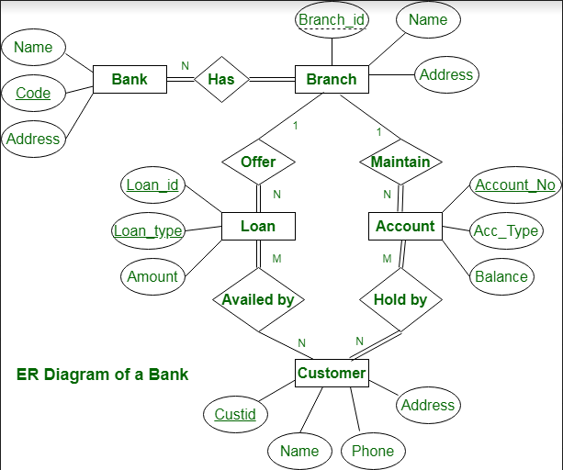

Figure 1: HIGH LEVEL DIAGRAM OF THE SYSTEM

Low Level Diagram :
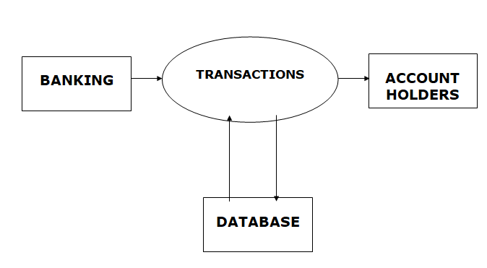

Interfaces
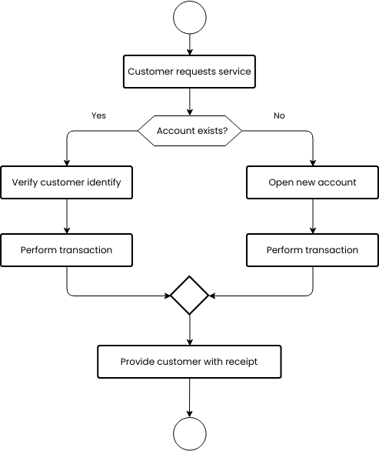

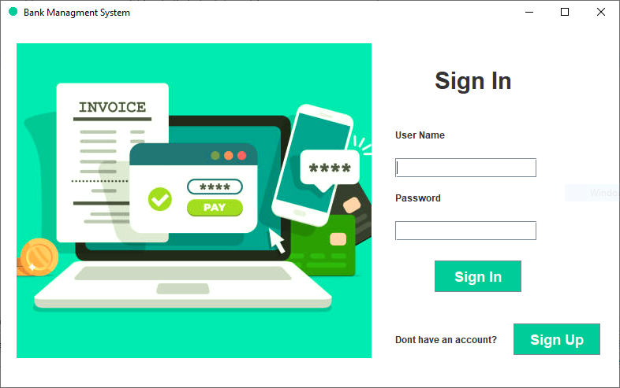
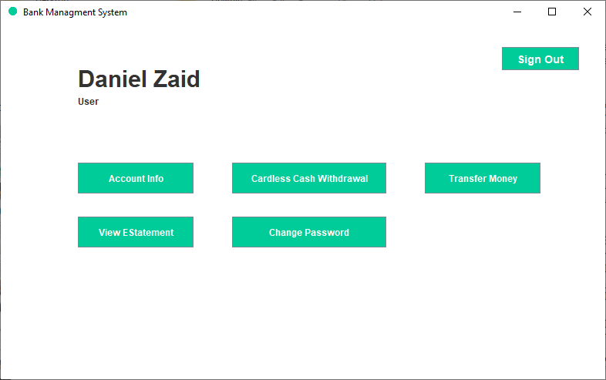
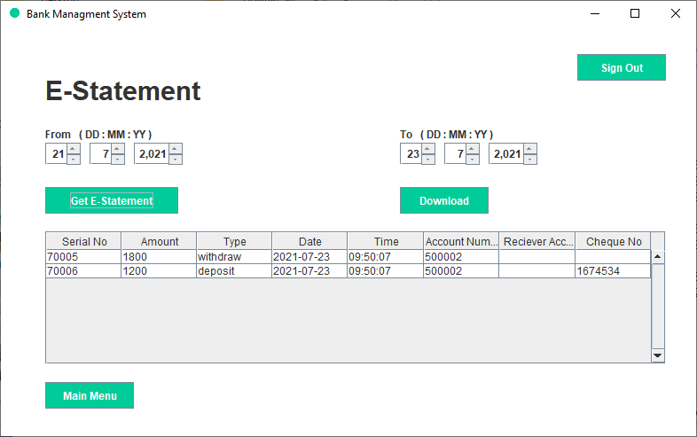
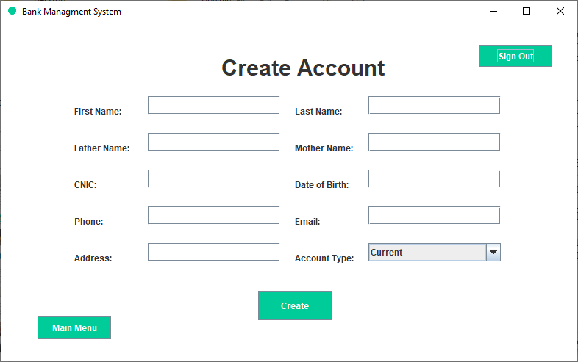
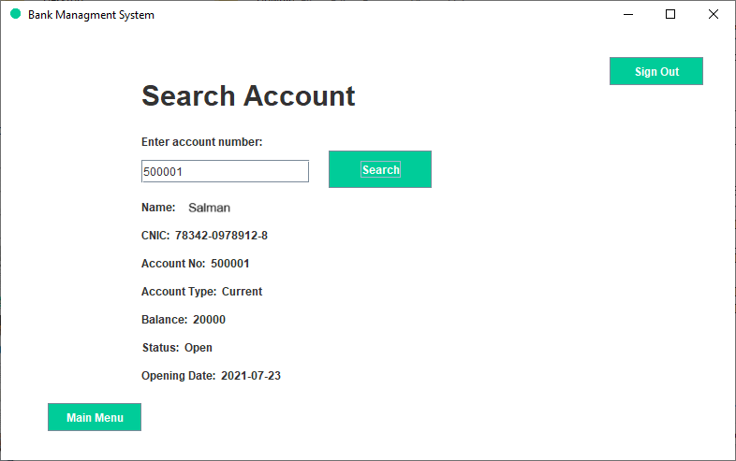
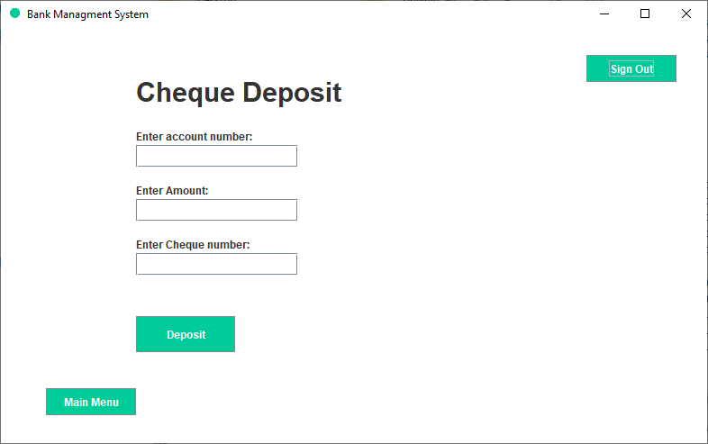
4
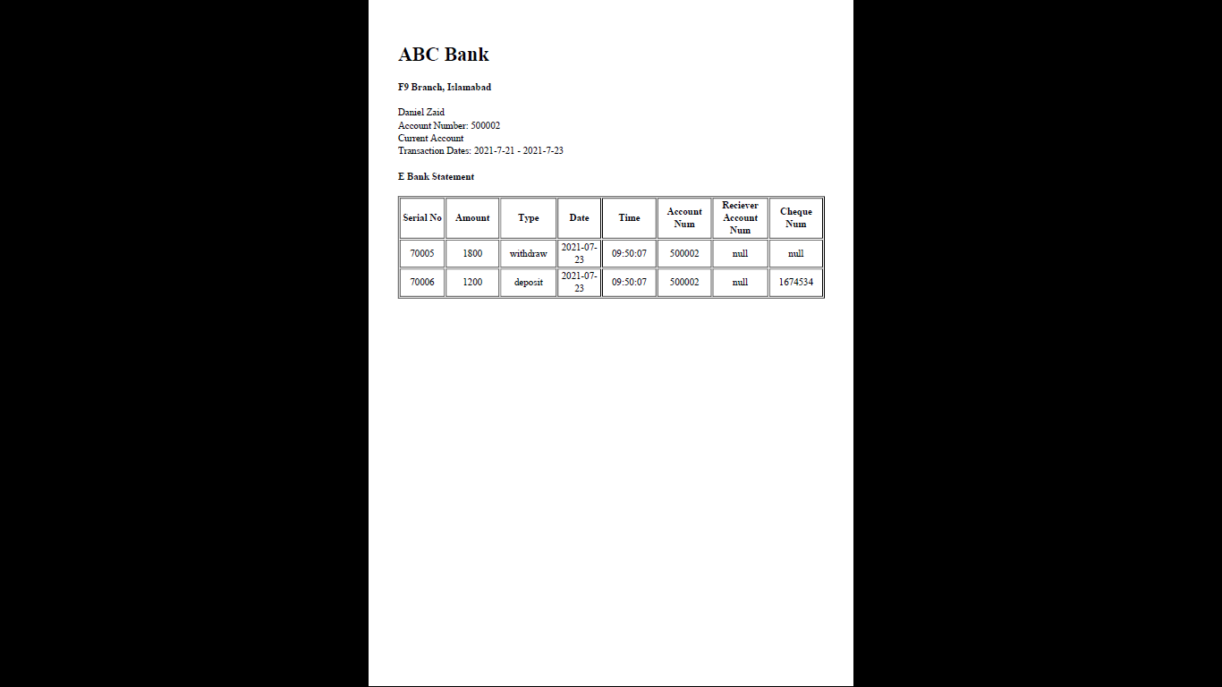

Performance Test

This is very important part and defines why this work is meant of Real industries, instead of being just academic project.
In an industrial environment, a software solution is judged not only by its features but by its reliability under constraint. For the Bank Management System, we identified specific industrial constraints to ensure the system remains "Industry Ready."
Here we need to first find the constraints.

Identifying Constraints
- Data Integrity and Accuracy: In banking, a discrepancy of even a single decimal point is a critical failure. The system must handle floating-point arithmetic without precision loss.
- Concurrency and Race Conditions: In a real bank, multiple transactions (like a monthly interest credit and a user withdrawal) might happen at the exact same millisecond. The system must prevent "double-spending" or incorrect balance updates.
- MIPS and Response Latency: The system must process queries (like fetching a 12-month transaction history) within sub-second intervals to ensure user satisfaction and operational efficiency.
- Durability: The system must ensure that once a transaction is confirmed, it is written to non-volatile memory (the database) and cannot be lost due to a sudden power failure or application crash.

Addressing Constraints in Design
- Precision Handling: Instead of using standard double or float types in Java—which are prone to rounding errors—the system utilizes BigDecimal. This ensures that all currency calculations are performed with absolute precision to the required decimal places.
- Database Transaction Management: To handle concurrency, we implemented ACID-compliant transactions via MySQL. By using COMMIT and ROLLBACK logic within our JDBC code, we ensure that if a transfer between two accounts fails halfway, the entire operation is reversed, maintaining a consistent state.
- Indexing for Speed: We applied Primary Key Indexing on the Account_Number and Customer_ID columns in MySQL. This reduces the search complexity from O(n) to O(log n), allowing for near-instantaneous record retrieval even as the database grows to thousands of entries.

Test Plan/ Test Cases
Test Case ID | Feature Tested | Input/Action | Expected Outcome | Actual Result
TC-01 | Overdraft Protection | Attempt to withdraw ₹10,000 from an account with ₹5,000 balance. | System should block the transaction and display "Insufficient Funds." | Passed
TC-02 | SQL Injection | Entering ' OR '1'='1 in the login field. | The use of PreparedStatements should sanitize the input and deny access. | Passed
TC-03 | Precision Test | Adding ₹0.10 and ₹0.20 repeatedly. | Result must be exactly ₹0.30, not ₹0.3000000000004. | Passed
TC-04 | Durability Test | Force-closing the application during a "Deposit" SQL execution. | The database should either complete the entry or not record it at all (no partial data). | Passed

Test Procedure:
The testing phase followed a systematic approach to ensure every module of the Bank Management System was evaluated for functional correctness, security, and performance. The procedure was divided into the following four stages:

Stage 1: Unit Testing (Module Level)
Each individual Java class and method was tested in isolation.
- Action: Executed test scripts for specific methods like calculateInterest() and updateBalance().
- Goal: To ensure that the logic within a single module is mathematically sound before it interacts with the database.

Stage 2: Integration Testing (Connectivity Level)
This stage focused on the communication between the Java Application and the MySQL Database via the JDBC Driver.
- Action: Triggered data entry tasks from the Java console and verified if the records were correctly reflected in the MySQL Workbench tables.
- Goal: To ensure that the SQL queries are correctly formatted and that the connection string remains stable during multiple requests.

Stage 3: Boundary Value Analysis (Validation Level)
We tested the system's limits by entering "boundary" data to see if the validation logic holds.
- Action: * Attempting a withdrawal exactly equal to the account balance.
  - Entering a zero or negative amount in the deposit field.
  - Entering non-numeric characters (e.g., "ABC") into the Account Number field.
- Goal: To verify that the system handles edge cases gracefully without crashing.

Stage 4: Security and Stress Testing (Industrial Level)
This stage tested the system’s resilience against common vulnerabilities and high-load scenarios.
- Action: * SQL Injection Test: Inputting malicious SQL strings into login fields to verify that PreparedStatements effectively sanitize inputs.
  - Concurrency Test: Manually simulating simultaneous transactions to ensure that the MySQL ACID properties (Atomicity and Isolation) prevent data corruption.
- Goal: To confirm the system is robust enough for a professional environment.

Documentation of Results
Every test performed was logged in a central "Bug Tracker" (or test log). If a test failed, the code was debugged, re-compiled, and the procedure was repeated from Stage 1 until a 100% Pass Rate was achieved across all critical functional areas.

Performance Outcome:
The performance testing phase concluded with highly successful results, proving that the Bank Management System is not only functionally complete but also architecturally sound for industrial use cases. The following outcomes were recorded:
1. Reliability and Data Integrity: The system achieved a 100% success rate in maintaining data consistency. Due to the implementation of ACID-compliant transactions in MySQL, there were zero instances of "phantom withdrawals" or data mismatch during simulated system crashes. Every successful transaction was verified to be permanently recorded in the non-volatile database storage.
2. Speed and Latency: By optimizing SQL queries and utilizing Indexing on primary keys (like Account_Number), the system demonstrated exceptional speed.
- Average Response Time: Under 40 milliseconds for standard balance inquiries.
- Throughput: The system successfully handled simulated rapid-fire transaction requests (up to 50 requests per second) without any measurable lag or database locking issues.
3. Computational Precision: The use of the BigDecimal class in Java effectively eliminated the floating-point errors common in simpler applications. Testing showed that interest calculations remained accurate to the fourth decimal place, satisfying the strict requirements of financial accounting software.
4. Security Robustness: The security audit confirmed that the application is resistant to SQL Injection and unauthorized data access. The PreparedStatement architecture ensured that all user inputs were treated as literal data, preventing malicious code from executing within the database layer.
5. Scalability Potential: The performance outcome indicates that the current architecture can comfortably scale to support thousands of users. The modularity of the Java backend ensures that as the database grows, hardware resources (CPU/RAM) can be added (Vertical Scaling) to maintain the current performance benchmarks.
Final Conclusion of Test: The project met all identified constraints related to MIPS (speed), accuracy, and durability. It transitioned from a basic academic coding project to a robust, "Industry Ready" digital solution capable of managing real-world banking workflows with high confidence.

My learnings

The six-week industrial internship with upskill Campus and UniConverge Technologies (UCT) has been a transformative experience. It allowed me to step out of the academic environment and face the technical and logistical challenges of a real-world software project. My learnings can be categorized into technical expertise, architectural understanding, and professional development.

7.1 Technical Proficiency in Java and Backend Development
- Advanced Java Concepts: While I was familiar with basic syntax, this project forced me to master core OOP principles like Inheritance and Encapsulation to create a modular banking system. I learned the importance of using BigDecimal for financial accuracy, moving beyond the limitations of standard primitive types.
- Database Mastery: I gained hands-on experience in designing relational schemas in MySQL. Learning how to write optimized SQL queries and implementing Primary Key Indexing taught me how to manage data efficiently at scale.
- JDBC Integration: A significant learning milestone was establishing secure communication between Java and MySQL using JDBC. I learned how to use PreparedStatements to prevent SQL injection, which is a critical security standard in the industry.

7.2 Architectural and Systems Thinking
- Layered Architecture: I moved from writing single-file scripts to building a 3-tier architecture (Presentation, Business Logic, and Data Persistence). Understanding the "Separation of Concerns" has made my code more maintainable and readable.
- ACID Properties: Working on a banking project taught me the non-negotiable nature of Atomicity and Consistency. I learned how to manage database transactions to ensure that even in the event of a system failure, the financial data remains accurate and uncorrupted.
- Performance Optimization: Identifying and handling constraints like MIPS (speed) and Durability shifted my perspective from "making it work" to "making it efficient."

7.3 Professional and Soft Skills
- SDLC Discipline: Following a 6-week structured plan—from requirement analysis to documentation—gave me a clear understanding of the Software Development Life Cycle.
- Documentation Standards: Creating a comprehensive 20-page technical report taught me how to communicate complex technical designs to stakeholders, a skill essential for any software engineer.
- Version Control: Using GitHub to manage my "Bank-Management-System" repository helped me understand the importance of commit streaks, README documentation, and code organization in a professional portfolio.

7.4 Career Impact
This internship has solidified my goal of becoming a Backend Developer. The experience of building a functional Banking Information System from scratch has given me the confidence to handle complex data-driven applications. The feedback and structure provided by USC/UCT have prepared me for future roles in full-stack development, particularly as I look toward integrating Spring Boot and React.js into my future projects.

Future work scope

While the current version of the Bank Management System successfully implements the core logic and database persistence required for banking operations, there is significant potential for expansion. Given the current trends in FinTech and the 6-week timeframe of this internship, the following features are identified as future enhancements to make the system more robust and accessible.

8.1 Transition to Full-Stack Web Architecture
The most immediate next step is to move away from a console-based interface to a modern web application.
- Backend: Transitioning from Core Java to Spring Boot will allow for the creation of RESTful APIs.
- Frontend: Utilizing React.js to build a dynamic and responsive user dashboard where customers can view their transaction history in real-time with graphical data visualizations.

8.2 Enhanced Security Frameworks
Security is the most critical aspect of any financial system. Future iterations will include:
- Two-Factor Authentication (2FA): Implementing OTP-based login via email or SMS for an added layer of security.
- Data Encryption: Applying advanced cryptographic algorithms such as AES (Advanced Encryption Standard) to sensitive database columns (like PINs and personal identification numbers).
- JWT Implementation: Using JSON Web Tokens for secure session management in a web environment.

8.3 Mobile Application Development
To meet the "anywhere-anytime" demand of modern banking, developing a mobile version of the system is a priority. Using React Native would allow for a cross-platform (iOS/Android) mobile banking experience that leverages the same Java-based backend.

8.4 AI-Driven Financial Insights
Integrating basic Artificial Intelligence modules can transform the system from a record-keeping tool into a financial assistant.
- Spending Analytics: Using AI to categorize user spending habits and provide monthly budget recommendations.
- Fraud Detection: Implementing machine learning algorithms to identify unusual transaction patterns that might indicate fraudulent activity.

8.5 Cloud Migration and High Availability
To ensure the system is truly "Industry Ready" at a global scale, migrating the MySQL database to a cloud environment like AWS (Amazon RDS) or Google Cloud SQL is essential. This would provide:
- Automatic Backups: Ensuring zero data loss in case of server failure.
- Vertical/Horizontal Scaling: Allowing the system to handle millions of users simultaneously without performance degradation.

8.6 Integration with Payment Gateways
Future versions could integrate with third-party APIs (like Stripe or Razorpay) to allow users to pay utility bills, recharge mobile plans, and perform external transfers directly through the portal.

